* Durable function are a little bit more complex then normal function <https://docs.microsoft.com/en-us/azure/azure-functions/durable/durable-functions-overview?tabs=csharp>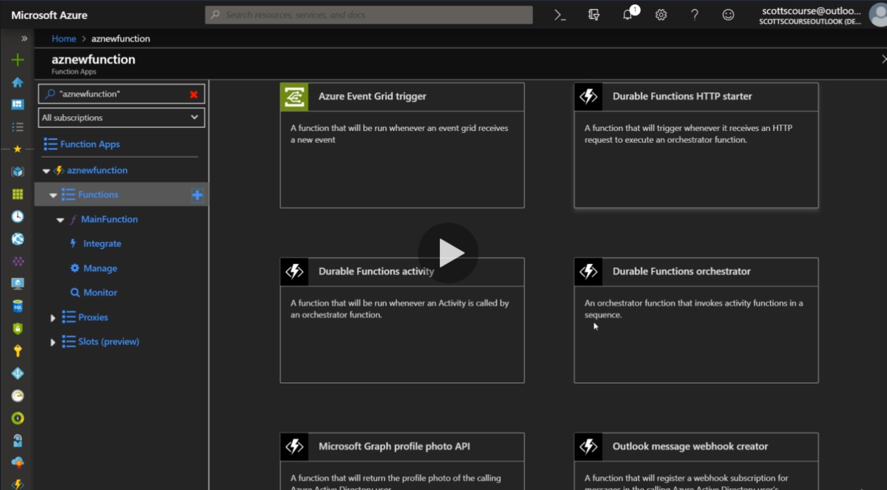
* We have to install an extension to create a durable function.
* *Durable Functions* is an extension of [Azure Functions](https://docs.microsoft.com/en-us/azure/azure-functions/functions-overview) that lets you write stateful functions in a serverless compute environment. The extension lets you define stateful workflows by writing [*orchestrator functions*](https://docs.microsoft.com/en-us/azure/azure-functions/durable/durable-functions-orchestrations) and stateful entities by writing [*entity functions*](https://docs.microsoft.com/en-us/azure/azure-functions/durable/durable-functions-entities) using the Azure Functions programming model. Behind the scenes, the extension manages state, checkpoints, and restarts for you, allowing you to focus on your business logic.
* While creation function is bind with a orchestration client.
* I this we can create multiple dunction and orcrestrate them along with each other.
* You cn get the output from a outputqueryurl
* We can also create functions in visual studio and import it in Azure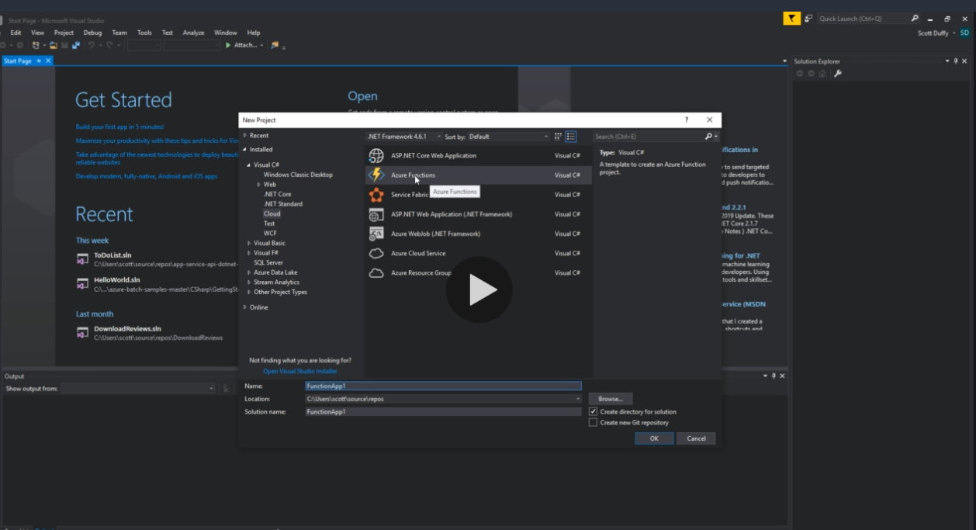
* After creation we can also publish the function from Visual Studio.
* 